2018

Jordan university of science and technology

**Presented to the Departments of**

Robotic pharmacy

Patient services ultimate edition robot

**Computer Engineering,**

**Network Engineering,**

**Software Engineering.**

Jordan University of Science and Technology

**Supervised by**:

***Dr.OSAMA AL-KHALEEL***

|  |  |  |
| --- | --- | --- |
| SE | 105020 | Ibrahim Baker Gharaibeh |
| CPE | 101604 | Baha Ahmad GDIESAT |
| NES | 104935 | Khaled Ahmad Hinde |
| CPE | 104833 | Anas Jaffar Bani-Hamad |

Abstract:

With increasing the numbers of patients, constitutes 65% of the hospital system and number of nurses 25% of the hospital system) in the hospital, we are trying to reduce the number of necessary routine moves and to increase the productivity of the work.

Smart phones provides a good options and specifications and provides an easy language to program their apps, Ex : Bluetooth , android studio.

building a hardware have become very easy ,cheap and reliable.

Background:

The nurses are spending a lot of time doing the same routine work which is to go to the hospital pharmacy and take the medicine and give it to the patient, this operation takes time and effort that we can save to use it in other important things.

Robotic pharmacy ultimate edition is a project based on the Bluetooth ,android OS and tow separated hardware (room/box and a conveyor belt).

overview:

the doctor can specify the patient name , type of medicine that he takes , the quantity and the time of the medicine.

the device then will give every patient his medication on time with the accurate amount and time.

Problem Statement:

In the United States of America the Nurses spend 42 minutes of each 8-hour resolving operational failures such as missing medications and broken or missing equipment ([Tucker 2004](https://www.ncbi.nlm.nih.gov/pmc/articles/PMC1713207/#b59)).

Other studies estimate that nurses spend from 10 percent ([Linden and English 1994](https://www.ncbi.nlm.nih.gov/pmc/articles/PMC1713207/#b32)) to 25 percent ([Miller, Deets, and Miller 1997](https://www.ncbi.nlm.nih.gov/pmc/articles/PMC1713207/#b39)) of their wasted time looking for missing medication.

our project gives you the solution.

it deals directly between the doctor's prescription and the patient medication so there will be absolutely no errors ,missing medications or wasted time.

project description:

the doctor of the hospital will enter the information of the patients.

Ex: patient name, medication name , medication amount/quantity , medication time etc...

the software will keep checking until the time come for the patient to take his medications.

the software well send a note to the hardware box/room to inform it when the time comes for the patient to take his medications.

then the hardware room/box should drop the medication on the conveyor belt.

the conveyor belt should take the medications to the patient.

the app notify the patient that the medicine is ready.

Project purposes & objectives:

reduce the number of necessary routine moves.

increase the productivity of the work by letting the nurses focus on the patients at all times.

reduce the number of missing medications.

give every patient his medication on the accurate time.

reduce wasted time of the nurses.

Prevent medications from being stolen by the nurses.

Project Stockholders:

Jordan university of science and technology.

Dr. Osama Al-KHALEEL.

Team members:  
 Bahaa GDIESAT.   
 Khaled Al-Hinde.  
 Ibraheem Al-GHARAIBEH.   
 Anas J. Bani-HAMAD.

System Users:

Doctors.  
 Patients.

# Proposed Work

Our box used to drop Drug for Patientin three times in one day , the box located in a Table with Wheels to locate it behind the patient .

The Drug Dropped in small Container then the patient take it with a water .

Components :

Hardware :

1. Arduino UNO R3 Board
2. HC-05 Bluetooth Module
3. DS3231 Real Time Clock
4. Solenoid Slim Lock
5. Android device

Software :

1. ${ARDUINO}^{®}$ software (IDE).
2. C/C++ programming.
3. Android programming

Description of the components:

Hardware :

1. Arduino UNO R3 Board:

The **Arduino Uno R3** is a microcontroller board based on the ATmega328 ([datasheet](http://www.atmel.com/dyn/resources/prod_documents/doc8161.pdf)). It has 14 digital input/output pins (of which 6 can be used as PWM outputs), 6 analog inputs, a 16 MHz crystal oscillator, a USB connection, a power jack, an ICSP header, and a reset button. It contains everything needed to support the microcontroller; simply connect it to a computer with a USB cable or power it with a AC-to-DC adapter or battery to get started.

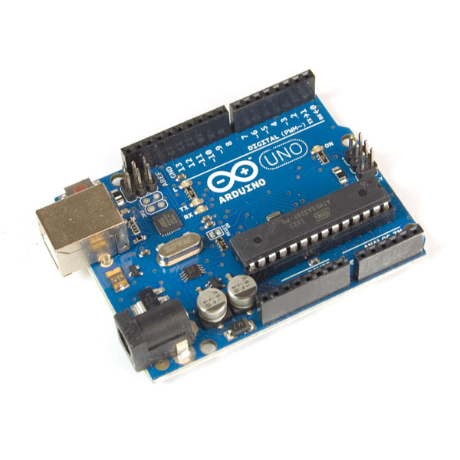

2-**HC**-**05 Bluetooth Module**:

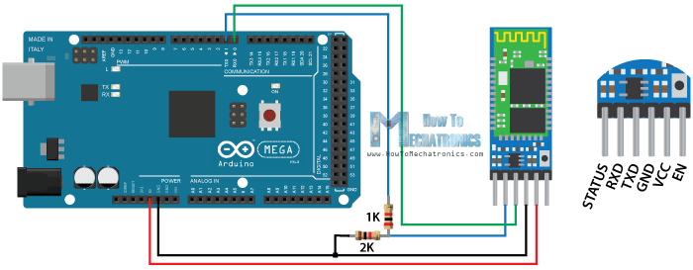 **HC**-**05 Bluetooth Module** is an easy to use **Bluetooth** SPP (Serial Port Protocol) **module**, designed for transparent wireless serial connection setup. Its communication is via serial communication which makes an easy way to interface with controller or PC.

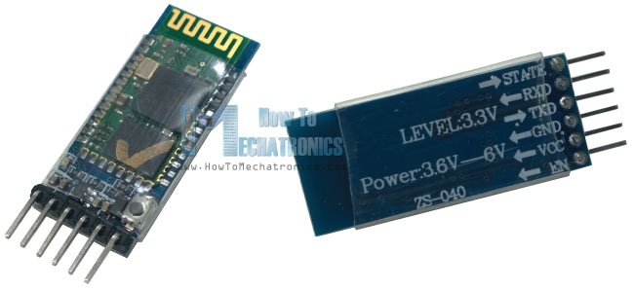

3 - DS3231 Real Time Clock :

The **DS3231** is a low-cost, extremely accurate I2C **real**-**time clock** (**RTC**) with an integrated temperature- compensated crystal oscillator (TCXO) and crystal. The device incorporates a battery input, and maintains accurate timekeeping when main power to the device is interrupted .

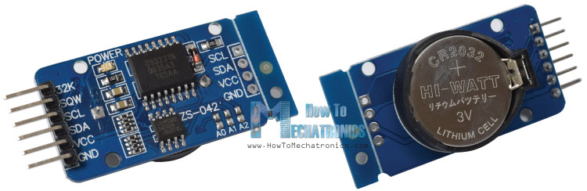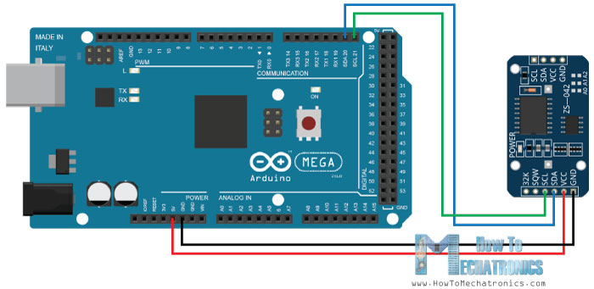

4 - solenoid slim lock :

A **solenoid** bolt is a type of electronic-mechanical **locking** mechanism. This type of **lock** is characterized by the use of a **solenoid** to throw the bolt. Sophisticated **solenoid** bolt **locks** may use microprocessors to perform voltage regulation, reduce power consumption, and/or provide access control.

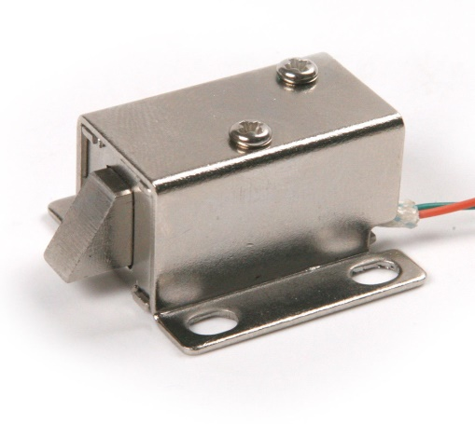

1. Android device :

**Android** is an array of software intended for mobile **devices** that features an operating system, core applications and middleware. An **Android device** may be a smartphone, tablet PC, e-book reader or any type of mobile **device** that requires an OS. **Android** is developed by the Open Handset Alliance, which is led by Google.

[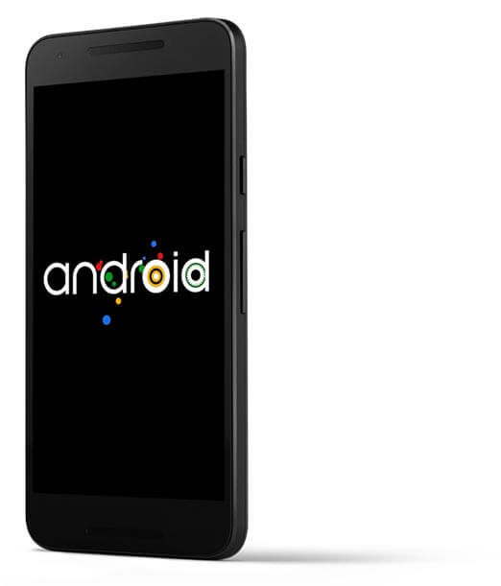](https://www.google.jo/url?sa=i&rct=j&q=&esrc=s&source=images&cd=&cad=rja&uact=8&ved=0ahUKEwirpov0sK_YAhUKbRQKHYpxCyMQjRwIBw&url=https://www.android.com/security-center/&psig=AOvVaw0V7ax_JUY-GtbMJYv8S7f9&ust=1514642414712448)

Software :

1. ${ARDUINO}^{®}$ software (IDE).

The Arduino board can be programmed by using IDE software, the code is written using C/C++ language. Then, the code is compiled and a HEX file is uploaded to the board's memory.

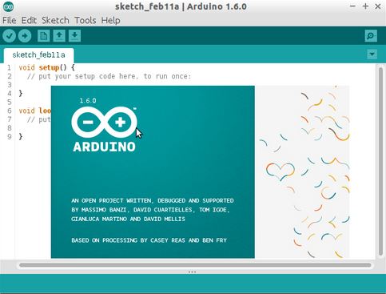

2- C/C++programming:

**C** is a high-level and general-purpose **programming language** that is ideal for developing firmware or portable applications. Originally intended for writing system software, **C** was developed at Bell Labs by Dennis Ritchie for the Unix Operating System in the early 1970s.

**C++** is a general-purpose object-oriented **programming** (OOP) **language**, developed by BjarneStroustrup, and is an extension of the **C language**. It is therefore possible to code **C++** in a "**C** style" or "object-oriented style." ... However, it was renamed **C++** in 1983.

1. - Android programming :

we will use Android Studio .  
SW-Eng Ibraheem prepared for this by taking android course elective in the university and advance android programming course outside the university .

and for the Bluetooth connection network-eng Khalid al-hindi who prepared this algorithm for the connection between the board and the phone.

1-public class BluetoothCommuunication: {

In this class we have a lot of variables and functions that will help us in make and mange Bluetooth connection and control message delivery between connected devices.

We also need thread to listen to the income connection that coming from master device (android application) to slave device (Bluetooth ship).}

2-public BluetoothCommuunication (Context context, Handler handler ){

first we need blueComm constructor to establish new Bluetooth data transfer with 2 parameter :

1-Context: the data that exist in each message we call it context

2-handler: send messages to user interface ,

}

3-privatesynchronizedvoidupdateUserInterfaceTitle() {

it will change based on connection status that will send it to handler }

______________________________________________________________________________________________

public synchronized int getStatus() {

it is an integer function that will return the status of our connection }

______________________________________________________________________________________________

public synchronized void startConnection() {

we use this function to establish the connection between master and slave

we need to accept on thread that will be on the master(server) side to listen(server mode) on incoming connection request.

So we will cancel each thread that try to connect with our master(android)except our thread

Also we cancel any thread running connection with our master.

Then our thread will start server mode

Finally, we will update UI through handler

}

______________________________________________________________________________________________

public synchronized void connect(BluetoothDevice device, boolean secure) {

|  |
| --- |
| Start the Connect Thread to establishe a connection to a remote device. |
| We have 2 parameters :  1-Blutooth Device :we identify here the device that we want to connect with,  2-Sceure :here will determine if our connection if secure or not  If (true):Secure  If(False):not secure  __________________________________________________________________________________________ |
| Public synchronized void connected(BluetoothSocket socket, BluetoothDevice |
| device, final String socketType) {   |  | | --- | | * Start the Connected Thread to begin managing a Bluetooth connection | |  | | socket The Bluetooth Socket on which the connection was made | | Cancel the thread that completed the connection  Cancel any thread currently running a connection and cancel the accept thread process because we only want to connect with one device | | run the thread that manage the connection and perform transmissions  Send the name of the connected device back to the UI Activity  To Update UI title through handler |   ___________________________________________________________________________________________  Public synchronized void stop() {  Stop all threads  }  ______________________________________________________________________________________________  Public void write(byte[] out) {  Write to the Connected Thread in an unsynchronized manner  out :The bytes to write  let’s see ConnectedThread#write(byte[])  we will Create temporary object  then Synchronize a copy of the Connected Thread  finally we will Perform the write unsynchronized  }  ______________________________________________________________________________________________   |  | | --- | | Private void connectionFailed() { | | Indicate that the connection attempt failed, in this situation we will  Send a failure message back to the user interface Activity  Through handler to update user interface title  Then we will Start the service again to restart listen step through our thread | |  |   }   |  | | --- | | Private void connectionLost() { | | Indicate that the connection attempt lost, in this situation we will  Send a failure message back to the user interface Activity  Through handler to update user interface title  Then we will Start the service again to restart listen step through our thread | |  |   }  Private class AcceptThreadextendsThread {  * This thread runs while try to make an outgoing connection  * with a device. Its already runsthrough; the connection may  * succes or fails.  Public AcceptThread(booleansecure) {   |  | | --- | | * This thread will run while they are listening for incoming connections. It’slook  * like a server-side client. It runs until a connection is accepted  * (or until refused)  Create a new listening server socket  } | |  |   } |

public void run() {

here we try to Listen to the server socket the socket was free( not connected)

// This is a blocking call and will only return on a

// successful connection or an exception

// If a connection was accepted

// Either not ready or already connected. Terminate

}

public void cancel() {

close socket on client side

}

_____________________________________________________________________________________________

private class ConnectThreadextendsThread {

/**

* This thread runs while trying to make an outgoing connection

* with a device. It’s already runs through; the connection either

* succeed or failed.

*/

// Get a BluetoothSocket for a connection with the

// given BluetoothDevice

public void run() {

here we will cancel the discovery process because it will reduce the speed of connection

// Make a connection to the BluetoothSocket

// This is a blocking call and will only return on a

// successful connection or an exception

// Close the socket

// Reset the ConnectThread because we're done

// Start the connected thread

}

|  |
| --- |
| Public void cancel() { |
| Close socket on server side |

}

private class ConnectThreadextendsThread {

* This thread already runs through a connection with a remote device.

* It handles all incoming and outgoing data

Get the BluetoothSocket input and output streams

public void run() {

// here we will stay listen to Input stream to receive data from paired device

But we have to share any incoming message with user interface activity through handler

}

public void write(byte[] buffer) {

/**

* Write to the connected OutStream

We write on the buffer (array)

We send a copy of any sent message to user interface (UI) activity

}

_____________________________________________________________________________________________publicvoidcancel() {}

Close Bluetooth socket

}

Feasibility Study and Constraints

-Technical Feasibility Study and Manufacturability Constraints :

# Software resources needed to get the Project done meets the need of our project and it can be done (not hard to achieve).

#Hardware needed for the box/room is existing as components but need to edit it's functionality a little bit to meet the requirements and the need of the project.

#Hardware needed for the Conveyor belt is existing but needs to be controlled from the hardware to meet the requirements of the project.

#Network needed to Communicate between the Software and the hardware exists but needs a code and a compression algorithm.

-Economy Feasibility Study and Constraints:

# Software resources needed to get the Project done are free.

#Network needed to Communicate between the Software and the hardware is a Bluetooth chip and its very cheap.

#Hardware needed for the Conveyor belt and the box is cheap.

#all manpower we need is a SW-Eng and Computer Eng and a Network Eng.

Health and Safety Constraints:  
any medicine should not be out of its container for more than 24 hours in the temperature it must be stored in.

-Site and Location (environment) Feasibility Study and Constraints:

after letting the hospitals use our system we can release a home edition for the people (so they will not forget to take their medicine).

-Financial Feasibility Study and Constraints:

Users (hospitals): they will realize that the hospital will not need more nurses to service the patients .

organizational (project releases): can sell it at a very high cost but the project does not cost that much for the organization so the project have a high profit for them.

also can sell it for the people so they can use it in their homes which means more profit.

social values constrains:  
if the people who are using our product are having some problems with it or have a new idea they can report it back to the team members so they will study it and do the changes required from them.

Assumptions:

# the project manager will divide the tasks evenly between the team members and himself taking into consideration what every team member is good at.

# the team members will submit their done tasks on time as scheduled (in the specified dates).

# the project manager will be taking into consideration the delayed submission of the team members works due to exams , other project ,home works and their Special emergency circumstance (being Humanitarian) when he builds the schedule.

# the work will be done in parallel.

# all the hardware components and the Software needed to build the project will be delivered to us on time as planned.

project life span (stages/phases) and methodology

Implementation phase:

# Building Hardware and Network Components.  
# Software and Hardware and Network Coding.  
# Components Testing.

#Integration.

Requirements analysis phase:

define System Needs and Requirements (Functional , Non-Functional, etc… ).

Risk Management:

|  |  |  |  |  |
| --- | --- | --- | --- | --- |
| Risks | Internal / External | Probability | Impact | Risk Response Plan |
| Late Delivery | Internal | 80% | Very High | Accept risk |
| Technology will not meet expectations | External | 40% | High | Avoid the risk |
| Changes in requirements | External | 60% | Medium | Accept the risk   Have contingency plan |
| Deviation from software engineering standards | Internal | 10% | Medium | Avoid the risk |
| Cost Overhead | Internal | 99% | Low | Accept risk |
| Misunderstanding the requirements | Internal | 0.1% | High | Have contingency plan |

Standards followed:

# weekly meetings  
 - discuss what we have achieved in the previous week.  
 - discuss what we will achieve in the next week.  
 - discuss the problems we have faced in the work.  
 - extra two meetings to combine the work (last two meetings)

# each function and button name must represent its functionality.

# the project manager assistant will take over when the project manager is not in the work/meeting.

**Project Scheduling and Major milestones:**

|  |  |  |  |
| --- | --- | --- | --- |
| **Task Name** | **Duration** | **Start** | **Finish** |
| **1. Introduction** | 1 Day | 2/11/2017 | 3/11/2017 |
| **2. Prefeasibility study** | 1 Day | 2/11/2017 | 3/11/2017 |
| **3. Project Planning** | 2 Days | 3/11/2017 | 5/11/2017 |
| **4. Analysis** | 6 Days | 5/11/2017 | 11/11/2017 |
| **5. Design and Development** | 20 Days | 12/11/2017 | 2/12/2017 |
| **6. Implementation** | 40 Days | 15/1/2018 | 25/2/2018 |
| **7. User Documentation** | 2 Days | 27/2/2018 | 29/2/2018 |
| **8. final testing** | 6 Days | 1/3/2018 | 7/3/2018 |
| **9. maintenance** | Depends on testing | 29/12/2018 | 1/1/2018 |
| **10. Delivery** | ………….. | 2/4/2018 | 2/4/2018 |

|  |  |  |
| --- | --- | --- |
| **Time Frame** | **Task To Be Completed** | **Status** |
| 2/11/2017 | * Identifying system requirements, scope, and implementation platform. | Done |
| 6/11/2017 | * Training on the implementation environment. | Done |
| 26/11/2017 | * Development and deployment of a simple pilot program | Done |
| 31/12/2017 | * Report preparation and presentation. | Done |
| January | * Field study and preliminary users’ feedback. | Planning |
| February | * Incorporating more requirements and users’ feedback. | Planning |
| March-April | * Source code Lock, followed by testing. | Planning |
| April-May | * Dissemination of research results. | Planning |
| May | * Final report and presentation. | Planning |

Roles and Responsibilities

Supervisor:  
Dr. Osama Al-KHALEEL

Instructor:  
Dr. Osama Al-KHALEEL

Project Manager:  
SE. Ibraheem Al-GHARAIBEH

Project Manager Assistant:  
Bahaa GDIESAT

Hardware eng. :  
Anas Bani-HAMAD  
Bahaa GDIESAT

Network Architect:  
Khaled Al-Hinde

Hardware programmers:  
Anas Bani-HAMAD

Developer:  
Ibraheem Al-GHARAIBEH

Testers:  
Bahaa GDIESAT  
Khaled Al-Hinde  
Ibraheem Al-GHARAIBEH

Technical process plan and methods used

in the software eng. we are using the Agile method.

reasons/why Agile:

# High level of communication between the stockholders and the team members.  
 - Reduce the misunderstanding in Requirements.  
 - Increase the user involvement level.

# Helps to break down the project into smaller parts.  
 - Parallel Processing.  
 - Managed easier by the team leader.  
 - focus on implementation and testing each part.  
 - ease of Error detection and correction.  
 - focus on Quality.

# Adaptable when Requirements change or new Requirements Appear.  
 - new Requirements or change in Requirements can be planned and managed in the next iteration.

# a fast method (decrease the chance of delays and decrease the chance of late in project delivery).

Project Approval

This Project was approved by:

# chancellor of the IT : < Professor Ali Shatnawie >

# Head of the Software Eng. Department :

<Doctor Loay Alawneh>

# Head of the Computer Eng. Department :

< Professor Moath jarrah>

# Head of the Network Eng. Department :  
< Professor Eyad Taqi-aldeen>  
  
and the approval of the supervisor  
< Doctor Osama Al-KHALEEL>

ANALYSIS PHASE:

Required

Devices and Hardware / software / OS .

## Hardware Required :  
 -Smart phone (and supports Bluetooth).  
 -Bluetooth Chip.  
 -a Conveyor belt.  
 -the Box/room components.

## Software Required :  
 - GOOGLE Android Studio.  
 - Arduino BT.

## OS Required :

- Android 5.0.1 or a Higher version of Android Operating System.

ANALYSIS PHASE: REQUIREMENTS

Functional Requirements:

|  |  |
| --- | --- |
| FEAT-1 | The System should Allow a the new doctors of the hospital to register throw the head of the hospital username and password . |
| FEAT-2 | The System should Allow the doctors to create a new patient profile. |
| FEAT-3 | The System should Allow the doctors to add/edit patients medications information(time , type and amount). |
| FEAT-4 | The System should Allow the doctors to delete a patient profile . |
| FEAT-5 | The System should Alert the patients when the medications are ready and to turn off that Alert when they command the system to turn it off throw the patient/user interface . |
| FEAT-6 | The System should send a message to the robot inform him about the type, time and the amount of the medicine. |

Logic modeling Decision Table:

|  |  |  |  |
| --- | --- | --- | --- |
| **Type of user Actions /** | Patient | doctor | The head of the hospital |
| Receive Alert | X |  |  |
| Receive the medications | X |  |  |
| Turn off Alerts | X |  |  |
| Enter medication Information |  | X |  |
| Add a new patient |  | X |  |
| Edit / delete patient |  | X |  |
| Delete a doctor |  |  | X |
| Add a new doctor |  |  | X |